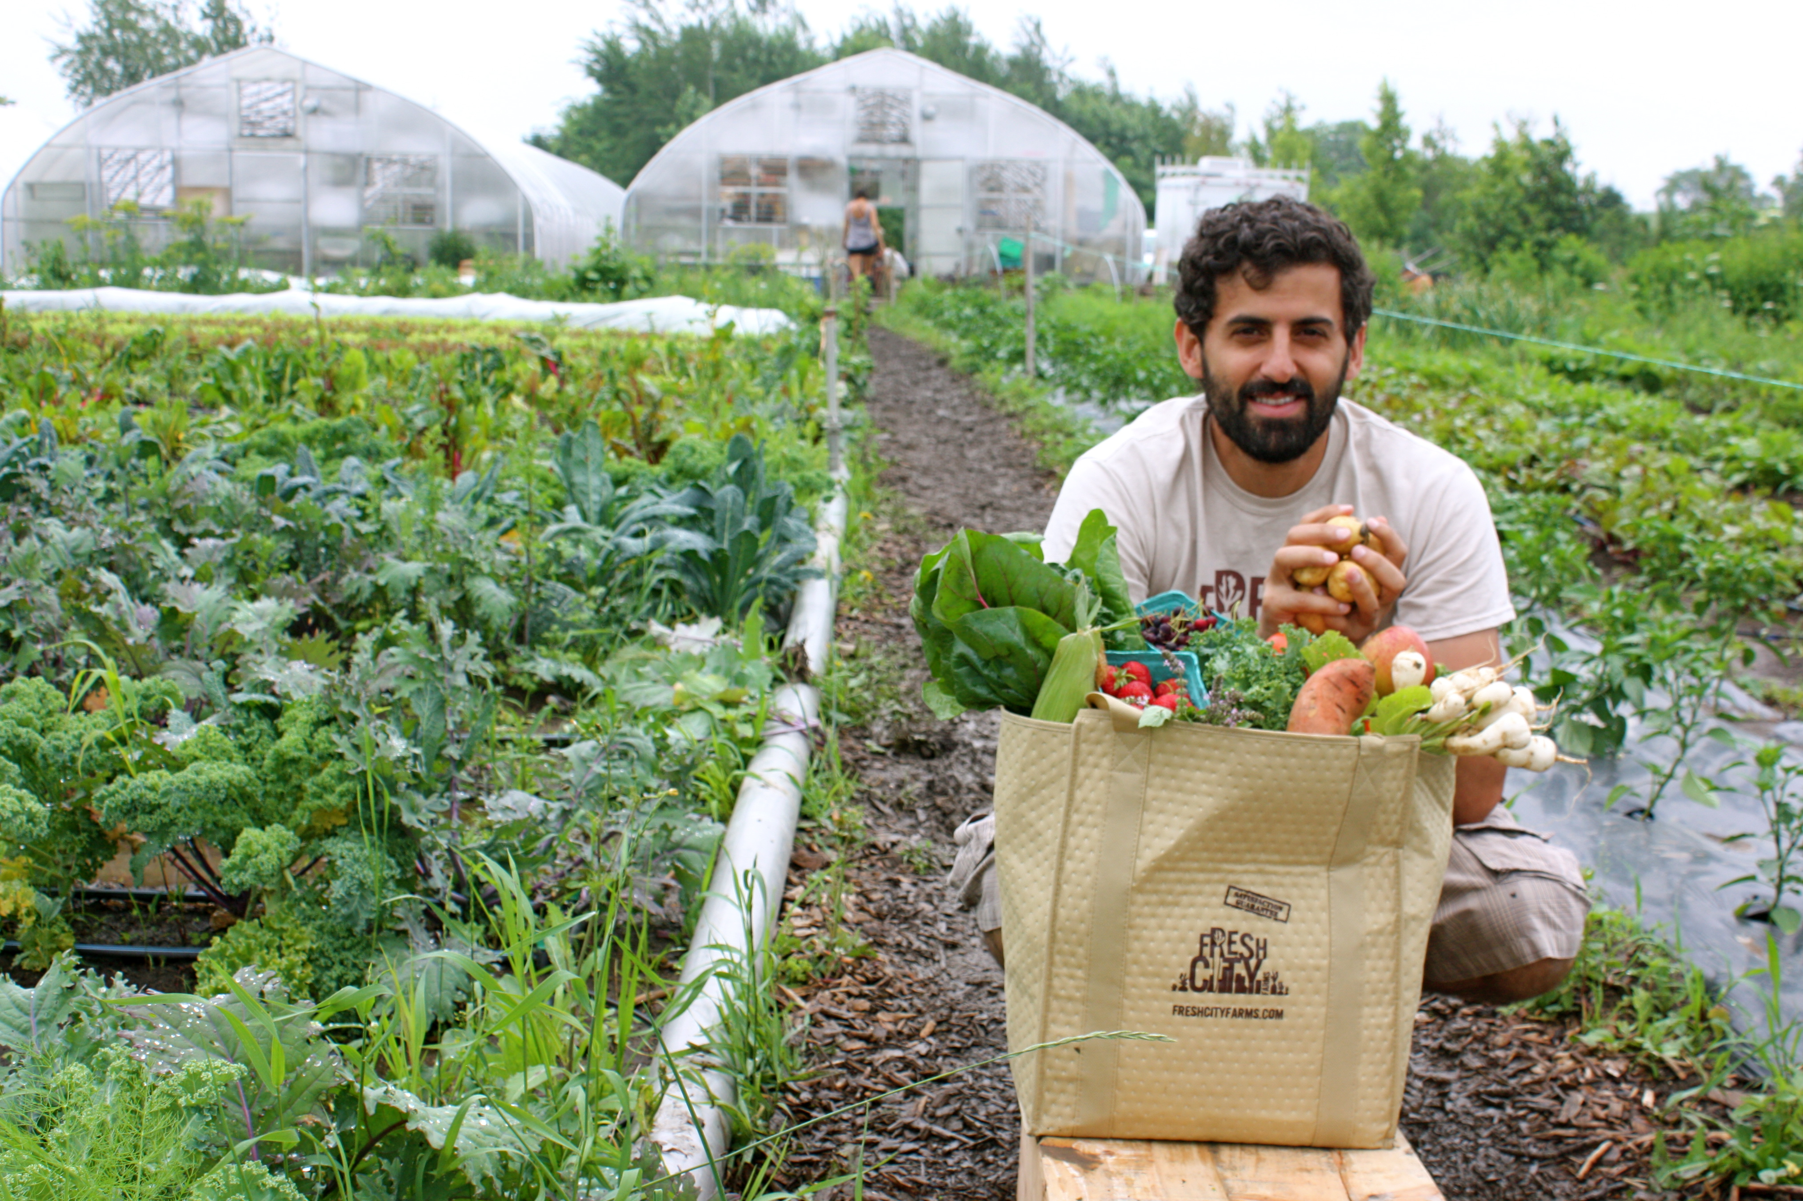

Interview with Ran Goel, Fresh City Farms – May 22, 2014
As humans we must add external material to our systems to keep us going physically. We call this eating food. But as humans with minds and spirits and fellow-humans around us, the food we eat is always more than just fuel. We imagine our food and make it interestingly before we eat it. When we imagine our food, are rows of cubicled animals awaiting slaughter in factories and drones spraying seedlings with pesticides our dream? There are alternatives. For Ran Goel, founder of TorontotheBetter enterprise Fresh City Farms, Toronto’s city-based farm, his food dreams come from his childhood. For his influential grandmother, who grew up on a co-operative farm, food was a central talking point. Far from the “Just Eat” slogan that circulates on signs around Toronto these days, suggesting that our only relationship to food is when we consume it, Ran’s family members had conversations about the how of food, how we make what we eat, whether it be the irrigation, the taste or the variety of the tomatoes and other edibles they grew. For much of the world this is still the relationship to food. But in North America, the myth that many kids think food comes from a refrigerator is, sadly, not far from the truth for many.
To help young and old recreate a healthier relationship with what we eat, TorontotheBetter member Fresh City Farms offers us a functioning farm in our own “backyard” of Toronto and a fresh good food delivery service. And most important perhaps, through Fresh City educational tours, we can learn that food is an idea as much as a consumable; it represents our values. And, it is our responsibility to shape it to fit our values. So conceivably the most important benefit provided by Fresh City to Torontonians are the educational opportunities, the chance to learn how to make what we eat. For details of Fresh City’s services see its TorontotheBetter directory listing at http://www.torontothebetter.net/2Bfreshcityfarm.htm

TorontotheBetter – “building Toronto’s Social Economy since 2004”.

